**Hunter Man**



**Session 2023 - 2027**

**Submitted by:**

Haseeb Afzal 2023-CS-123

**Supervised by:**

Prof. Dr. Muhammad Awais Hassan

& Sir. Laeeq Khan Niazi

**Course:**

CSC-102 Object Oriented Programming

Department of Computer Science

**University of Engineering and Technology**

**Lahore Pakistan**

**Table of Contents**

**1.** **Short Description of Game:** 3

**2.** **OOP CONCEPTS:** 3

**3** **Rules & Regulations:** 4

**4** **Goal of the Game:** 4

**5** **Wireframes of the Game:** 5

**6** **CONCLUSION:** 9

**Game Introduction**

In Hunter Man, you control a Robotic Man navigating through spaceShip. Your mission is to kill Enemies and Dodge their Bullets And Win the Game.

**Object Oriented Concepts**

* **Interfaces**:

Interfaces are utilized to establish a pact for classes to execute particular functionalities. The IMovement interface, for instance, delineates methods for object mobility, allowing developers to devise bespoke mobility behaviors by adhering to this interface. This promotes adaptability and compatibility, as various mobility behaviors can be seamlessly incorporated into the framework.

* **Enumeration**:

Enumerations are utilized to portray a fixed set of named constants, offering a more articulate and type-safe approach to manipulate data. Inside the framework, enumerations are harnessed to delineate the direction and type of enemies, enriching code readability and maintainability. Through the utilization of enumerations, developers can effortlessly discern and oversee diverse enemy types and directions within the game.

* **Singleton Pattern**:

The Singleton pattern guarantees that just one instance of a class is generated, which proves especially valuable for overseeing global game state or resources. Within the framework's context, the Singleton pattern is employed with the Game class to assure the presence of only one instance of the game at any point. This thwarts inadvertent replication of game instances and streamlines access to game-related functionalities..

**Rules and Regulations**

Hunter Man has to defeat all different types of enemies in order to win. For this purpose

* Hunter Man must avoid hitting the enemies by himself
* Hunter Man must avoid the rocket of enemies
* Hunter Man should defeat all different enemies using bullets

**Goal Of The Game**

The objective of the game is straightforward and logical. Players must adhere to rules and regulations to achieve the highest possible score. The hero's task is to eliminate all dangerous enemies to emerge victorious with a top score. That's the primary aim of this game.

**Wireframes:**

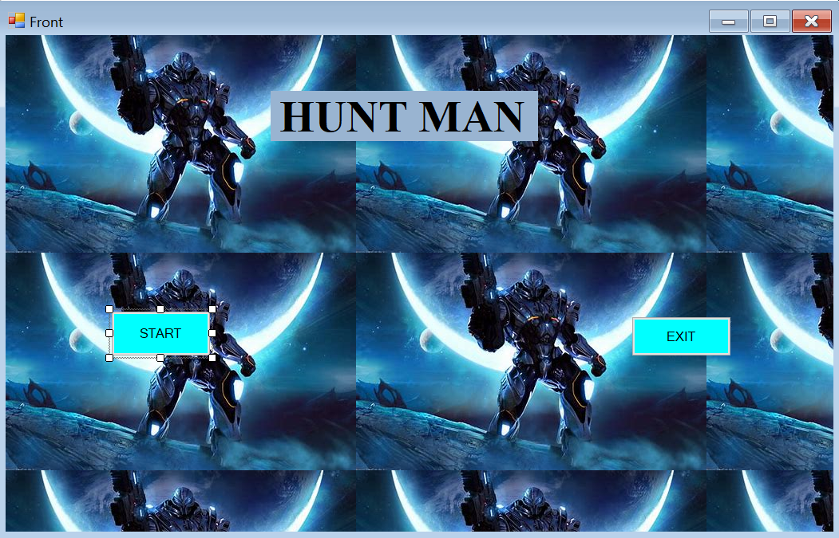

Figure 1-MainPage

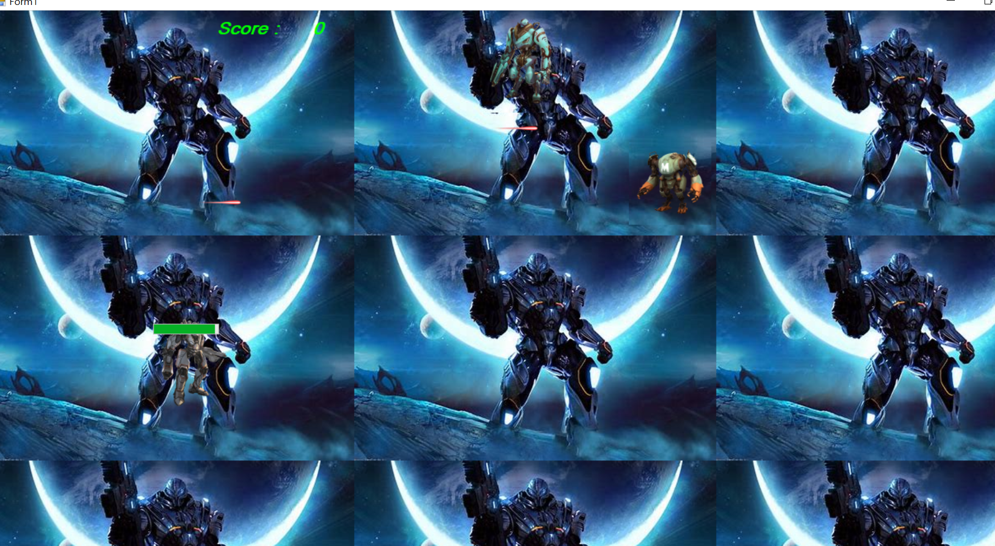

Figure 2-GameScreenShot1

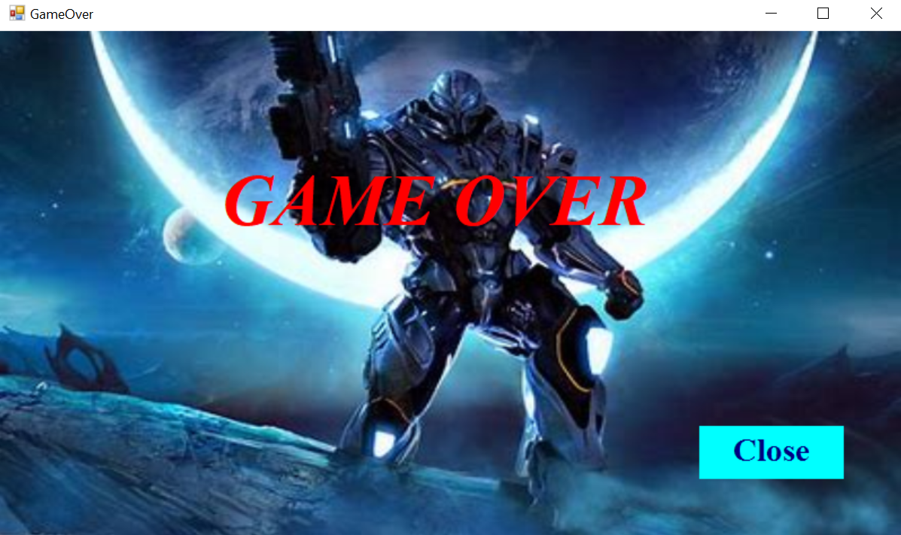

Figure 3-GameOver

**Conclusion**

In summary, our Hunter Man game is crafted using an intelligent approach known as object-oriented programming, which aids in maintaining tidy code organization. We leverage elements like interfaces, serving as blueprints for various game behaviors, and enums, acting as lists of options for specific game aspects. Beneath the surface, a robust framework handles much of the heavy lifting, ensuring appealing graphics and responsive gameplay. This framework allows us to focus on injecting fun and excitement into the game, free from technical complexities. Overall, our game aims to be accessible yet challenging, promising an engaging experience that keeps players enthralled. So, prepare to command your ship, strategize your maneuvers, and emerge as the ultimate champion of the cosmos!